LEP – Sub Committee

LEP - Lancashire Skills and Employment Board

Private and Confidential: NO

Date: Wednesday, 3 April 2019

Lancashire Skills Hub Update

Report Author: Dr M Lawty-Jones, Director of the Lancashire Skills Hub,
Michele.Lawty-Jones@lancashirelep.co.uk

Executive Summary

This paper provides an overview of activity since the last formal committee meeting in November 2018.

Recommendation

The Board is asked to note the update.

Background and Advice

1. Careers Education, Information, Advice and Guidance (CEIAG)
  - The Lancashire Enterprise Adviser Network has grown from 129 schools and colleges in November 2018, to 130. Of the 130, 117 have been matched with at least one volunteer business leader (Enterprise Adviser). Since the start of the 2018/19 academic year (Sept 2018 – February 2019), there have been over 80,000 employer encounters involving young people from across the Lancashire area. Typical encounters range from traditional careers fairs, interview days, speed networking, enterprise weeks, dragons’ den, apprenticeship assemblies and guest speakers.

  - The general feeling across the network is that schools and colleges are becoming more familiar and comfortable with this type of activity which in turn is driving up the demand of local employers. Therefore, a key priority moving forward is to increase the network of employers across Lancashire who will agree to support schools in whatever capacity they can. The Hub and Inspira will be teaming up with the Careers and Enterprise Company (CEC) to be part of a national campaign, 'Give an Hour', which will align with the Lancashire Skills Pledge, to encourage new employers to get involved. The campaign is being run in a select number of LEP areas across the Country. A task group has been created to take this forward. It is anticipated that the work will be completed by the end of the summer.

  - The focus of the Enterprise Adviser Network is supporting schools to achieve Gatsby Benchmarks 5 and 6 which focus on ensuring that young people have a minimum of one employer encounter each year from Year 7 to Year 13, and that one of those encounters is in the workplace. The Grant Offer from the Careers and Enterprise Company has targets for achievement of these Benchmarks: 50% of schools and colleges within the network to achieve the Benchmarks by August 2019 and 75% by August 2020. The current achievement level is 52% (35%) achieving Benchmark 5 and 49% (45%) achieving Benchmark 6.

  - The Careers and Enterprise Company convened an Enterprise Coordinator training and sharing good practice event in Leeds on the 12th and 13th February 2019. Enterprise Coordinators from Lancashire were invited to deliver good practice workshops over the two days, focusing on their approach to standardisation and use of the TRACKER careers planning tool. Over 200 delegates from across the UK attended these workshops. The Careers and Enterprise Company has also made a request to come and spend time shadowing the Lancashire team, recognising good practice in the area.

  - The Careers Hub pilot for Lancashire commenced in September 2018. As previously reported the Careers Hub covers Burnley, Pendle and Blackpool and aims to support all 30 schools and colleges to meet all 8 of the Gatsby Benchmarks by 2020. The lead school for the Hub is Shuttleworth College in Burnley. Ruth England, Head Teacher currently represents Lancashire on the CEC Head Teacher Advisory Group and has also recently joined the Blackpool, Blackburn with Darwen and Lancashire School Improvement Board as Careers Hub lead and to provide a conduit to the Lancashire Skills and Employment Board.

  - Careers Hub meetings have been held in Blackpool and Burnley and Pendle this term with a focus on evaluation, career planning and work place visits. All schools and colleges within the Careers Hub have also received funding from the Careers and Enterprise Company through the Virtual Wallet system. Providers have commenced the delivery of provision which includes Young Enterprise, FutureFirst, Volunteer it Yourself, Digital Advantage, EDT and Opus. The provision includes encounters with employers and will support progression against Benchmarks 5 and 6. Schools and Colleges within the Hub will also receive an allocation of £2,000 each from the Central Hub Fund this term to support achievement of the wider set of Benchmarks over this and the next academic year; plans will be submitted outlining how the funds will support progression against one or more Benchmarks to release the funds. The funds are made up of funding from the Careers and Enterprise Company and match from Blackpool Opportunity Area, and Burnley and Pendle Councils.

  - The focus this academic year is supporting schools to achieve 4 Benchmarks as an average. The achievement is currently an average of 3.4 Benchmarks. A small number of schools are on track to achieve 8 Benchmarks this academic year.

  - The Careers Hub Enterprise Coordinators work very closely with Enterprise Coordinators across the rest of Lancashire, ensuring that the learning from the Careers Hub is cascaded to all institutions. The Lancashire Enterprise Adviser Network and Careers Hub Annual Conference will be held on the 20th June 2019 at Park Hall, Charnock Richard and will facilitate the sharing of best practice with a focus on linking curriculum learning to careers (Benchmark 4). The key note speaker is Sir John Holman, creator of the Gatsby Benchmarks and Committee members are welcome to attend the conference.

2. European Structural Investment Funds (ESIF)
2.1 The recommendations from the November Committee were discussed at the ESIF Committee in January, regarding allocation of remaining European Social Funds in the programme. Work is now ongoing with DWP to plan direct calls under investment priorities 1.4 and 2.2; it is likely that remaining funds under other investment priorities and 1.4 will be allocated to opt-ins as per the discussions in November.

2.2 The Education Skills Funding Agency (ESFA) opt-in procurement process has been completed and contracts issued. The Skills Hub attended the Evaluation Panel and was able to comment on process. Projects will commence from the 1st April 2019, as current projects end on the 31st March. The following providers have secured the contracts:
1.1 Skills Support for the Unemployed People Plus (change)
1.2 NEET provision Preston's College (no change)
1.4 Community Grants WEA (new provision)
2.1 Skills Support for the Workforce The Growth Company (change)
Meetings have been undertaken to support transition where new providers have secured contracts. Tripartite meetings have also been held by the ESFA with providers and the Skills Hub to ensure that the requirements of the LEP are fully understood and to agree reporting processes, including Steering Groups which will feed into the Committee.
2.3 Discussions are on-going regarding the transfer of the Strategic Partnership Manager roles that are currently funded through the 1.1, 1.2 and 2.1 ESFA opt-in project. A verbal update will be provided at the meeting.
2.4 The Escalate on-line referral tool to support people on their journey into work was launched in April 2018. The system includes all ESF funded projects targeting adults, and has been expanded to include the National Careers Service, college activity aimed at supporting adults into work and Job Clubs. Phase two of the system is currently being developed. This includes: improved reporting, note on funder, click to call and printable results.
2.5 Following on from the positive feedback from the marketplace attendees at the Escalate launch events, the Lancashire Adult Skills Forum decided to hold a further 7 regional events to support cross project working. The aim of the events was to bring together front line workers across the ESF projects and other providers to enable them to start some positive conversations and to facilitate an increase in cross project referrals and progressions. The third event took place in Blackpool on the 25th January 2019. 95% of participant's feedback is that the event completely met their expectations with over 80% feeding back that they would welcome additional partnership networking events.
2.6 From April 2018 until 14th March 2019, 2387 searches were made on the Escalate system. The top 3 sectors searched for remain Retail, Customer Service and Hospitality & Catering. The highest support requests have been for confidence, mental health support, support with IT and the use of IT, and support with CVs and interviews. Intelligence regarding needs is being fed into the Adult Skills Forum to help shape local provision.
2.7 The Employer Skills Forum brings together partners to ensure that ESF provision for employers across Lancashire supports the strategic outcomes defined within the Lancashire LEP Skills and Employment Strategic Framework and adds value. The key focus of the forum currently is to ensure clarity of the skills support offer for employers both through existing mechanisms e.g. BOOST Support Directory/Skills Hub Support Directory and ensuring intermediaries are fully aware of the skills offer. An event is to be organised for April/May to bring together intermediaries and providers delivering the employer facing ESF skills provision to ensure full awareness of the offer. It is intended that this will include BOOST Business Relationship Managers, and Economic Development representatives from the districts, as well as other intermediary organisations.

3. City Deal

3.1 A City Deal review is currently underway. The review is being undertaken by independent consultants, Steer, and will focus on both the commercial and residential sites earmarked for development. The outcome of the review will be fed into the City Deal Skills and Employment Steering Group to help shape future activity.
3.2 Following on the success of last year's programme, the City Deal 'Bridge the Gap' (the Lego Bridge building game in which young people are challenged to span the River Ribble and find out about construction careers) continues to go from strength to strength. In the first 3 months of 2019 alone the programme has been delivered in a total of 11 schools across the City Deal area of Central Lancashire. A full evaluation report will be prepared at the end of the current academic year to highlight the numbers of schools and pupils engaged during the 2018/19 academic year.
4. Social Value
4.1 The Skills Hub have recently undertaken a review of the social value metrics currently in place across LEP projects with a view to aligning them with the National Framework, The National Themes Outcomes and Measures (TOMs). The TOMs have been developed by the Social Value Taskforce in collaboration with the Local Government Association National Advisory Group and represents a major breakthrough in establishing a simple, intelligible methodology and reporting standard for social value.
4.2 The TOMs utilises Government Office Green Book unit values to ascribe a financial value to profiled and actual outputs to inform procurement at tender stage and provide an ongoing performance management and reporting framework.
4.3 These revised measures have now been adopted as part of the monitoring and reporting of the Growth Deal programme and embedded in the procurement process for Boost 3 and as part of the assessment criteria for Rosebud Finances business loans.
5. Growth Deal
5.1 The Growth Deal programme continues to deliver positive employment and skills outputs across the project portfolio.
5.2 As highlighted in the recent report to the Growth Deal Management Board (12th December 2018), the programme has generated circa £5.5m in social value to date in employment and skills outputs (excluding benefits attributable to local spend and employment).
5.3 These outcomes have been delivered across a range of metrics including workforce development, apprenticeship provision, providing employment opportunities for priority groups (unemployed residents, NEET's etc.) and school engagement (see Appendix 1 for the infographic).
5.4 An amount of underspend (c£16m) has been identified in the Growth Deal programme. The LEP Board has agreed a process for reallocating the funding, which is focused on existing projects and projects submitted for the Growth Deal 3 submission which were not allocated funding due to the level of Government funding awarded. The latter included a number of pipeline skills capital projects which were compiled to justify a pot of Growth Deal skills capital. Those providers that submitted into the pipeline have been contacted and given the opportunity to submit a project template for consideration against other projects that were submitted under Growth Deal 3.

6. Apprenticeship Update
6.1 An Apprenticeship Action Group has been established, in-line with the recommendation from the November committee, to review the drop in Apprenticeship starts in Lancashire in academic year 2017/18. A report from the group is provided under a separate agenda item.
7. Technical Education
7.1 The Technical Education Vision for Lancashire was launched on 30th November, with over 80 attendees, including employers, education and training providers, local authorities and government bodies attending. The spotlight panel on digital was well received, with good insights from employers on the future of Industry Placements for T Levels. Attendees requested continued action through regular conferences. The next is being planned with a provisional date of 24th May 2019. The launch was supported by a 16 page summary of the Lancashire Technical Education Vision which has already had to go to reprint due to its wide reach. The press release can be accessed here: https://www.lancashireskillshub.co.uk/uncategorised/lancashire-sets-2030-vision-technical-education-drive-countys-economic-growth/ .
7.2 The Skills Hub responded to the Education and Skills Funding Agency consultation on funding for T Levels (response circulated via email for comment). The Lancashire Principals' Group and the Association of Colleges were included in discussions for the response. Whilst the adaptations to the current funding formula seem, in the main, reasonable for allocation of additional funds for T Levels, there is still concern overall at the level of the basic funding formula for Further Education, and for the additional costs for Industry Placements, including co-ordination and travel.
7.3 The Teach Too project with The Lancashire Colleges is now in its final stages. The Lancashire Skills Hub, along with The Lancashire Colleges and Digital Lancashire were one of 3 areas to present the local findings of the project to a 100+ audience at a national Association of Colleges dissemination event in London. Locally, the project has exceeded targets, reaching 33 employers and over 180 college staff. An evaluation report is currently being compiled – initial feedback from those involved has been excellent.

7.4 Work in the Routeway Networks continues, with the Digital Routeway Network having held a workshop looking at how development needs can be identified and supported. An innovative input to the workshop helped to develop communications strategies with employers. A report, funded by the Gatsby Foundation, which maps recent FE delivery to labour market information has been completed by EMSI and this will be used to lead discussion on future need in forthcoming meetings.

7.5 Awareness is continuing to be raised regarding Technical Education pathways (Apprenticeships and T Levels), with presentations to groups of FE staff, Information, Advice and Guidance groups and Work Based Learning Providers having taken place. Further events include a presentation to UCLAN staff.

8. Marketing and Communications
8.1 Twitter followers have increased from 1,475 as of 5th November 2019 to 1,707 on 20th March 2019. A twitter campaign was undertaken during National Apprenticeship Week, highlighting the benefits of recruiting Apprenticeships and showcasing Lancashire case studies, in partnership with the Lancashire Work Based Learning Forum. Some additional information includes:

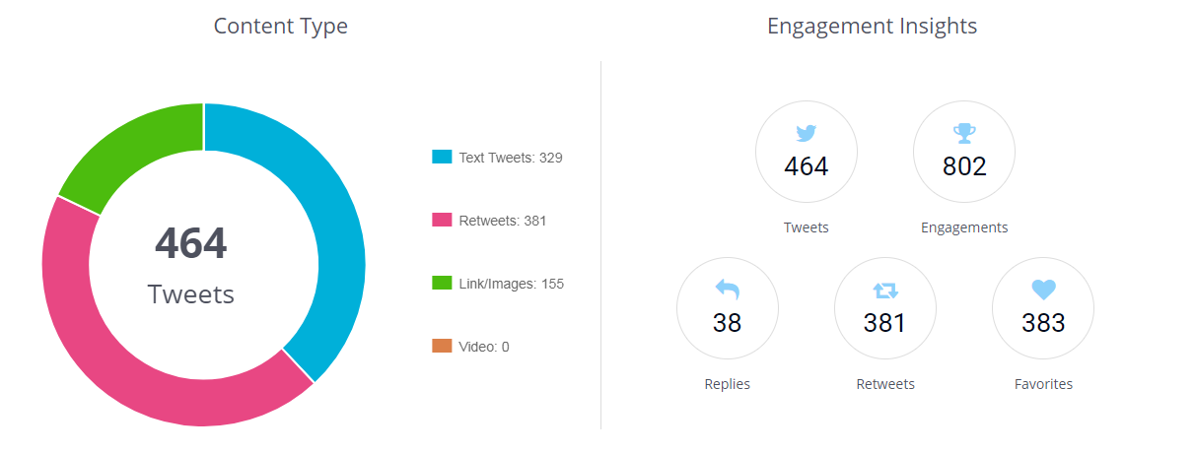
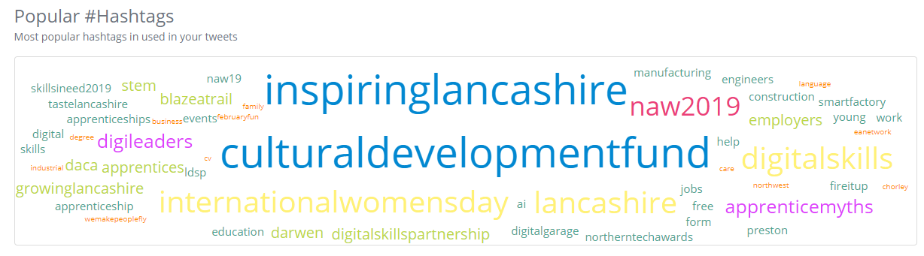

8.2 Sara Gaskell and Kerry Harrison supported the judging of the Red Rose Awards, judging the In-House Training and Digital Company categories.
8.3 Press releases were issued for the launch of the Technical Education Vision, as referenced previously, and also to report the award of Digital Skills Innovation Funds to Lancashire:
http://www.thebusinessdesk.com/northwest/news/2038734-lancashire-wins-share-of-digital-skills-funding-from-government
8.4 The Local Democracy Report, Paul Faulkner, did an excellent write up regarding technical education as a result of attending the launch event: https://www.lep.co.uk/news/lancashire-to-lead-the-way-in-new-alternative-to-a-levels-1-9515016
9. Digital Skills Partnership
9.1 An update in relation to the development of the Lancashire Digital Skills Partnership is provided as a separate agenda item.

List of Background Papers

Paper | Date | Contact/Tel
N/A

Reason for inclusion in Part II, if appropriate
N/A

Previous reporting figure

